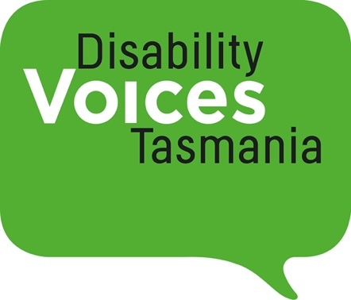

Conversations about Disability Pride – art and connection
I’m proud about what we do together and for each other – there’s something powerful about coming together by choice
We hope that you are interested in this project which will be both online and with art workshops in Hobart, Launceston, and Devonport.

Zoom Conversations Thursdays 7-8:30pm
you can attend one or all of the zoom conversations
28th September
14th October
27th October
Art Workshops 10-4pm
Hobart: Saturday October 8th
Kickstart Arts, New Town
Devonport: Saturday October 22nd
Paranaple Art Centre Creative Space
Launceston: Sunday October 30th
10-3 Interweave Arts, Launceston
Morning tea and Lunch included
Numbers are limited so to ensure that people get the most out of the project we would like you to tell us a bit about yourself
This project includes three facilitated two hour Zoom conversations and a one-day canvas painting workshop in each of the three cities. All Zoom sessions will be captioned.
All art supplies provided. Morning tea and lunch provided.
You need to attend at least one Zoom Conversation to attend the workshop.
All venues are wheelchair accessible with accessible toilets.
Please let us know if you require an Auslan interpreter.
…we don’t necessarily feel pride all the time

Expression of interest
Name
Phone
Email
Emergency contact

1.What interests you about this project?
2.Would you like to be with a group of other people with disability where we listen and talk about ideas about disability pride?
3. Do you like painting or would like to have a go?
4. What would you need to fully contribute to the workshop.
5. Which Art Workshop would you like to attend?
Hobart
Launceston
Devonport
Please email this form to projects@disabilityvoicestas.org.au by 21st September
Articles you might like to read.
https://www.yacvic.org.au/ydas/blog/mac-disability-pride
https://wwda.org.au/blog/bringing-disability-pride-to-sydney/

